|  |  |
| --- | --- |
| **Ex. No. 8** | **Cross Site Scripting (XSS)** |
| **Date of Exercise** | 25/10/23 |

**Aim:**

To perform a Cross Site Scripting attack using testfire.net

**Lab Environment:**

To carry out the Experiment, you need:

• Penetration testing operating system [ Kali Linux / parrot]

• Web browser with Internet access

• Administration privileges to run the tools

**Description:**

**Cross Site Scripting Attack:**

Cross-Site Scripting (XSS) attacks are a type of injection, in which malicious scripts are injected into otherwise benign and trusted websites.

**Site: testfire.net**

The AltoroJ website is published by IBM Corporation for the sole purpose of demonstrating the effectiveness of IBM products in detecting web application vulnerabilities and website defects.

**Implementation:**

1. Go to the site testfire.net

2. In the search bar type the Cross Site Scripting scripts

3. <h1>This page is hacked</h1> using this script we can display the

Text on main page.

4. Run other scripts to manipulate the site. For example:

<a href="http://www.owasp.org?test=$varUnsafe">link</a> it will redirect to owasp page when we click on the link present in the main.

**Output:**

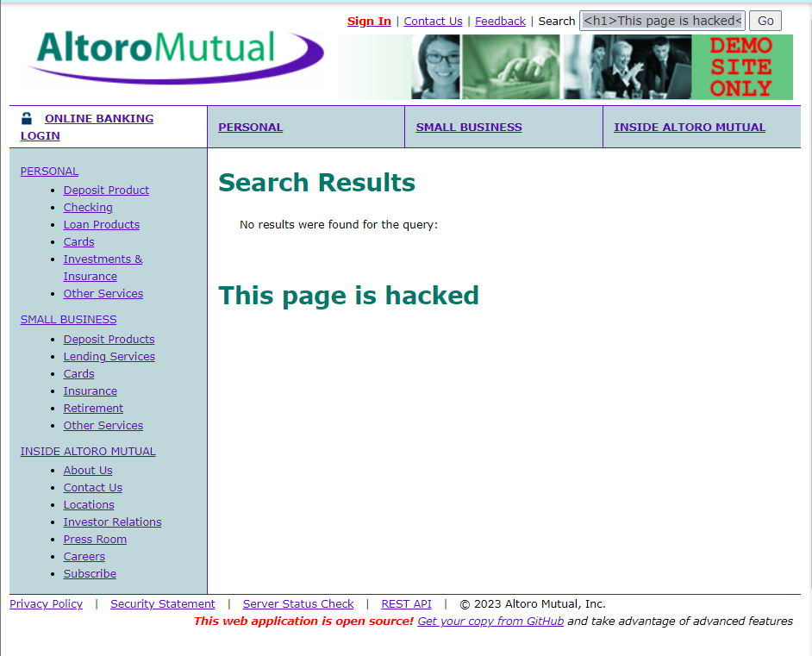

**Result:**

The Cross Site Scripting attack using site testfire.net was implemented successfully.